***Spring boot with Rest API using Spring Data With Relationship***

***One to many relationship***

***Trainer Student***

***Tid(PK) Sid(PK)***

***TName SName***

***Tech age***

***TsId (FK)***

***Starter - 🡪 Web***

***Starter 🡪 JPA***

***Dependency 🡪 mysql connector***

***Starter -🡪 Devtools : when we do any changes auto fresh the application. We need to use this type of starter only in dev mode.***

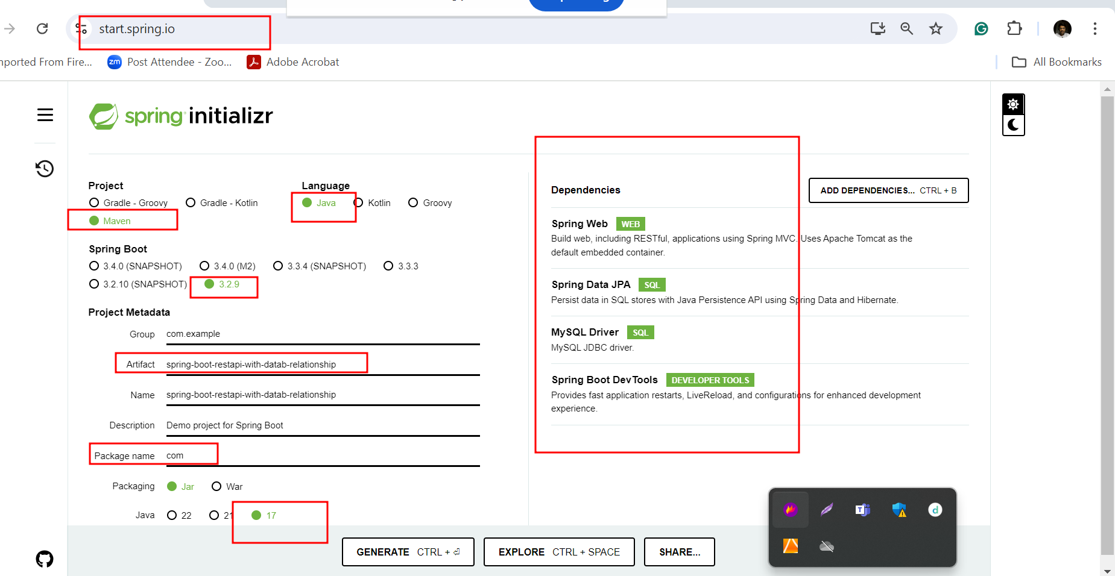

***create table trainer(tid int primary key,tname varchar(25), tech varchar(30));***

***create table student(sid int primary key,sname varchar(25), age int, tsid int, foreign key(tsid) references trainer(tid));***

***insert into trainer values(1,'Ravi','Java');***

***insert into student values(100,'Seeta',21,1);***

***insert into student values(103,'Meeta',25,null);***

***Trainer and Student Relationship is loosely couple : Aggregation***

***Employee and Insurance : rightly couple : composition***

***@OneToMany(cascade = CascadeType.REMOVE) // if we delete any trainer record automatically associated student record also delete.***

***Json data to store trainer and student with one end point***

***{***

***"tid":1,***

***"tname":"Raj",***

***"tech":"Angular",***

***"listOfStudent":[***

***{"sid":104,"sname":"Reeta","age":24,"tsid":1},***

***{"sid":105,"sname":"Leeta","age":25,"tsid":1}***

***]***

***}***